S100A8 and S100A9 Expression and Purification Protocol
Craig Vander Kooi, Drew Vartia, Brian Dattilo

Day 1 - TRANSFORMATION

Transform S100A8/A9 wild type plasmid into BL21(DE3) chemically competent cells using standard protocols. Grow overnight at 37°C on LB/Agar plates supplemented with 100 µg/mL ampicillin.

Day 2 - STARTER CULTURE

From glycerol stocks or from freshly plated transformants, inoculate a 50-100 mL LB liquid culture supplemented with 100 µg/mL ampicillin. Allow these cultures to shake at 37°C overnight.

Day 3 – GROWTH and EXPRESSION

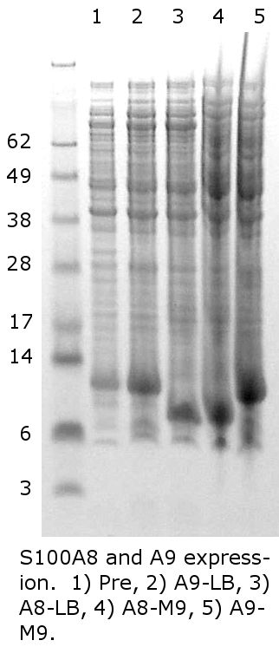
In the morning, inoculate each 1 L LB (or M9) culture flask with 10-15 mL of the overnight culture. While shaking, monitor growth at 37°C until OD₆₀₀ is approximately 0.8. A pre-induction sample can be made by pelleting 200 μL of the pre-induced culture. Discard the supernatant and add to the pellet 25 μL saturated urea solution followed by 25 μL 2x SDS loading buffer. When ready, heat sample and analyze 10 μL by SDS-PAGE.

Figure 1. S100A8/A9 expression. 1) A9 pre induction, 2) A9 post in-duction, 3) A8 post induction.
1 2 3
62
49
38
28
17
14
6
3

Expression is induced with 1 mM IPTG. Allow to express for 4 to 5 hours. Prepare a post-induction sample in the same manner. Harvest the cells by centrifugation at 5000 x g for 15 minutes. Discard the supernatant and freeze pellet for long term storage. Figure 1 shows the result of LB expression of S100A8 and S100A9. With BL21(DE3), the expression of A8 and A9 are not tightly controlled as shown in lane 1. Nevertheless, expression yield is very high.

Day 4 – LYSIS (adapted from Maniatis, Molecular Cloning, 2nd ed.

Prepare the following buffers:
A) 50 mM Tris-HCl, 100 mM NaCl, 10 mM β-ME at pH 8.0
B) 50 mM Tris-HCl, 100 mM NaCl, 10 mM β-ME, 4.0 M GnHCl at pH 8.0

For each gram of cells add 3 mL buffer A supplemented with 1 mM EDTA. To this, add 10 mg lysozyme per mL of lysis solution added. Mix the lysis solution for 15’ on ice. If necessary, add MgCl₂ to a final concentration of 10 mM and a small amount of DNaseI. Sonicate on ice for 5 minutes with a 50% duty cycle. Centrifuge the lysate 40,000 x g for 15’ at 4°C. Discard the supernatant.
Homogenize the pellet using the same volume of buffer A supplemented with 0.5% Triton X-100 and 1 mM EDTA. Centrifuge 12000 rpm for 15’ at 4°C. Repeat homogenization process twice more. For the final homogenization step, mix buffer A and B to make a final GnHCl concentration of 1 M (3:1 ratio), and supplement with 0.5% Triton X-100 and 1 mM EDTA. Centrifuge at 40,000 x g for 15’ at 4°C. Discard the supernatant and retain the pellet. We suspect long term exposure of A8/A9 to GnHCl may lead to permanent misfolding or covalent modification so work quickly at this and subsequent stages.

Day 5 – HYDROXYAPATITE PURIFICATION

Prepare the following buffers:
A) 20 mM potassium phosphate at pH 7.5
B) 500 mM potassium phosphate at pH 7.5 (sodium phosphate will precipitate at 4°C)

Solubilize pellet in buffer B from Day 4 (4M GnHCl) supplemented with protease inhibitors. Centrifuge ~40,000 x g for 15’ at 4°C and discard pellet. (If purifying the heterodimer, mix the two samples at this point. Subsequent purification step will separate any excess homodimers from the thermodynamically preferred heterodimer.) To the supernatant, add 3x sample volume of buffer A to dilute the GnHCl to 1 M. EDTA should not be present as it chelates Ca²⁺.

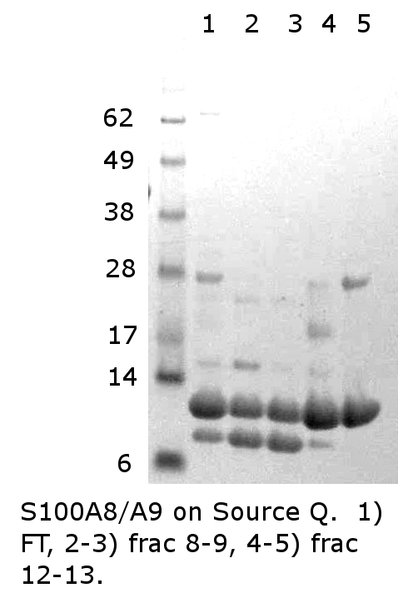
Equilibrate the column with buffer A. Load the column and wash with a further 3 column volumes of buffer A. Elute protein with 100% buffer B over 2 column volumes. Collect relevant fractions and analyze by SDS-PAGE (Figure 2, lane 1). No improvement in purity is obtained with a linear gradient. Pool fractions with the protein of interest and dialyze overnight against 20 mM Tris-HCl, 0.5 mM DTT, 0.5 mM EDTA at pH 8.0.
38
28
17
14
6
1 2 3 4 5

Figure 2. Source Q purification of A8/A9. Lane 1, post HA, lanes 2-3, frac 8-9, lanes 4-5, frac 12-13.

Day 6 – SOURCE-Q PURIFICATION

Prepare the following buffers:
A) 20 mM Tris-HCl, 0.5 mM DTT, 0.5 mM EDTA at pH 8.0
B) 20 mM Tris-HCl, 0.5 mM DTT, 0.5 mM EDTA, 1.0 M NaCl at pH 8.0

Filter dialyzed sample through 0.45 μm syringe filter. Equilibrate SourceQ with buffer A. Load and wash with 3 column volumes of buffer A. Set up a gradient from 0% buffer B to 50% buffer B over 18 column volumes with a 2 column volume gradient delay at the end. Collect relevant fractions and analyze by SDS-PAGE (Figure 2 lanes 2-5). Note the separation of A8/A9 heterodimer from excess A9 homodimer (excess A8 homodimer would elute earlier than heterodimer if present). Pool appropriate fractions. In this case excess A9 was successfully separated from the stoichiometric A8/A9 complex.

